
Catamaran Isla Mujeres

Cancun isla mujeres
Catamaran tour to Isla Mujeres

From your hotel you will be picked up for the ride to Cancun where you will board the catamaran after check-in.
First you will sail to the underwater museum where you will snorkel accompanied by a guide and with snorkel gear of excellent quality. After snorkeling, you'll be back on the boat and offered unlimited drinks by the amazing crew. Lunchbuffet will be provided on Isla Mujeres at the IceBar. Here you can choose from dishes from an extensive buffet and various drinks. In the free time you have here you can use the sunbeds for free. You will then re-board the boat and be provided with entertainment with tequila and music. In the meanwhile the captain is on his way tob ring you tot he north side of Isla Mujeres. Here you will have about 1.5 to 2 hours of free time. One goes into the center and rents a golf cart, the other goes to chill on the beautiful beach. After free time on the island, you will sail towards Cancun, along the way the captain will stop for some water activities (weather permitting). Once back at the port, the van will be waiting to take you back to the hotel.
Practical information:
- Catamaran tour lasts approximately 7 hours (excluding transport)
- Departs at 2 times at 10 am and 12 pm, at the latter you can enjoy the beautiful sunset
- Snorkel, goggles and life jacket are of excellent quality and included in the cost
- Unlimited water, soft drinks, beer and cocktails on board.
- Buffet lunch and drinks on board are included
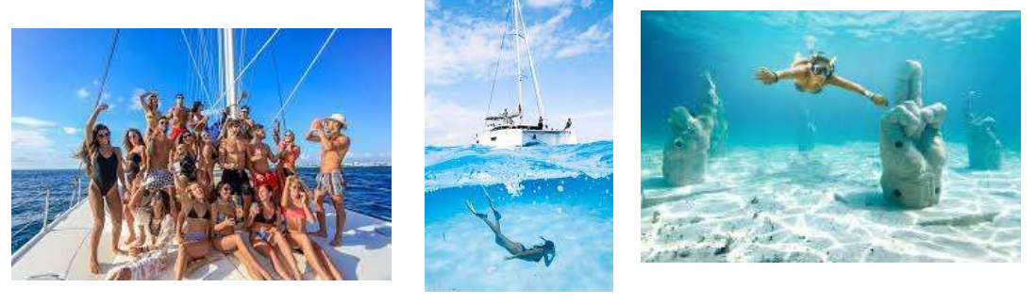
- Restrooms provided on board of the Catamaran

