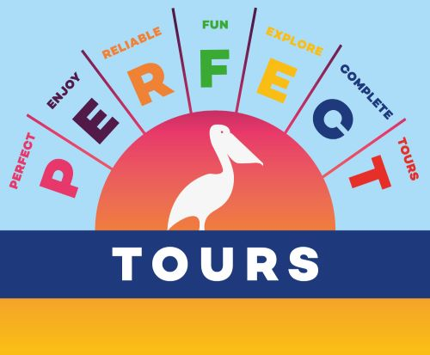
Snorkeling El CIelo

COZUMEL
THE FAMOUS SNORKEL TOUR

Take the ferry to Cozumel for an unforgettable day on this beautiful island. Upon arrival on the island, you can walk in 3 minutes to the harbor where the small boats (max 30 people) depart for the most famous snorkeling trip.

You will sail to the famous reefs of Palancar and Columbia to admire the underwater world with the guide who will accompany you. After you have swum over the reefs you will return to the boat that will take you to the starfish sanctuary El Cielo, here you can spot several starfish and with a bit of luck also beautiful sea turtles.

After half an hour, you will leave for El Cielito for a snack served from a surfboard and where the stingrays swim past you to eat the fallen ceviche and fruit.

Practical information:
- Duration of the tour is aprox. 4 hours
- Departs every full hour between 10 AM and 3 PM
- Snorkel, goggles and life jacket of excellent quality and included in the cost
- Unlimited water, soft drinks, and margaritas on board (maximum 2 beers per person)
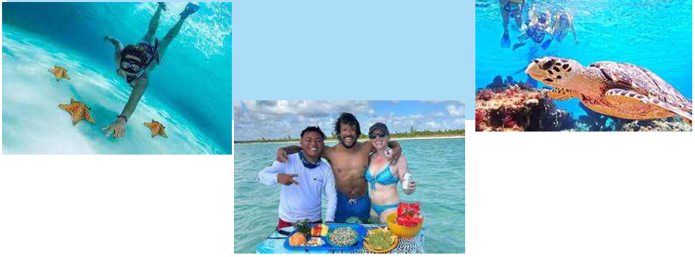
- A snack with guacamole, ceviche and fresh fruit

